Croatian National Theatre in Zagreb
Trg Republike Hrvatske 15 p.p. 257 10000 Zagreb, Croatia

Tel/fax: ++ 385 – (0)1 – 4888 – 400/4888 – 404
http://www.hnk.hr/ e-mail: intendantica@hnk.hr

SUBJECT: Call for Submission of Offers for walls with frames and doors and a wreath to decorate the stage, Croatian National Theatre has initiated a procurement procedure and has directed this Call for Submission of Offers.

Pursuant to Art. 18, Para. 3 of the Public Procurement Act (Official Gazette number 90/11, 83/13, 143/13, 13/14 – Decision by the Constitutional Court of the Republic of Croatia) for annually estimated value of procurement less than HRK 200,000.00 for goods and services, or HRK 500,000.00 for works excluding VAT (so-called low-value procurement), the Contracting Authority is not obliged to undertake a public procurement procedure as stipulated by the Public Procurement Act.

1. DESCRIPTION OF THE SUBJECT OF PROCUREMENT
The subject of procurement of walls with frames and doors and a wreath to decorate the stage, , and in line with the Bill-of-Quantities found in the Appendix to this Call. The estimated value of the subject of procurement: EUR 18.000,00 € excluding VAT.
Procurement record number: E-BAG 40-/21

2. PROCUREMENT CONDITIONS
manner of implementation: Contract
deadline of implementation: the offeror is obliged to deliver the goods 30 days from the day of conclusion of the contract
duration of contract: 12 months
validity period of offer: 60 days from the date of opening the offer
place of implementation: Croatian National Theatre in Zagreb, Trg Republike Hrvatske 15
Deadline, manner and conditions of payment: Charges and payment will be carried out after the signing of the accepted invoices by the Contracting Authority: Croatian National Theatre in Zagreb, all in accordance with actual delivered quantities from the Bill-of-Quantities.
The Contracting Authority shall be paid within 7 days of the day of signature of this Contract 50% and 50% of the amount shall be paid of the day of delivery of the subject of the Contract.
price of offer: The offer is submitted with the respective price in EUR/HRK, the price is fixed. The price of the offer must include all costs and discounts, excluding value- added tax which is expressed separately after the price of the offer.
Offer selection criterium: the lowest price

3.PROOF OF CAPABILITY:
1. Tender list (completed, certified and signed by the offeror’s authorised person)
2. Bill-of-Quantities (completed, certified and signed by the offeror’s authorized person)
All evidence of capabilities that are attached to the offer may be submitted by the offeror as an uncertified copy.
Following the opening of the offer, the contracting authority may request from the most favourable offeror originals or certified copies of all the documents that were requested, and which are issued by the relevant bodies.

If the offeror intends to cede part of the subject of procurement for execution to one of more sub-contractors, then the offer must state information on part of the subject of the procurement that is intended to be given for execution to the sub-contractor and information on all proposed sub-contractors (name, enterprise, abbreviated enterprise name, headquarters and VAT ID no.).
The offeror is obliged to attach a statement from the sub-contractor of accepting to place proprietary resources at the disposal of the offeror for the purpose of undertaking the subject of procurement. The statement should clearly indicate the subject of procurement (name of the subject of procurement) to which the statement relates.

4. INTEGRAL PART OF THE OFFER

Tender list (completed and signed by the offeror);
Bill-of-Quantities (completed and signed by the offeror);

5. DEADLINE AND MANNER OF SUBMITTING THE OFFER

Deadline for submitting the offer is 11 am on 20 July 2021.

The offer is to be submitted on e-mail:iivanjek@hnk.hr

The pages of the offer are to be designated such that the total number of pages followed
by a slash (/)then the sequential number of the page (e.g. 24/1) or opposite to that, i.e. the sequential number of the pages followed by a slash (/) then the total number of pages (e.g. 1/24). Corrections to the offer in paper form must be done such that they are visible or evident (e.g. deletion or removal of letters or print). Corrections must along with the cited date be verified using a legally binding signature and seal of the economic entity’s authorised person.

6. MISCELLANEOUS

Notice relating to the subject of procurement:
Irena Hirc Ivanjek: e-mail: iivanjek@hnk.hr
Notice relating to the results of the conducted procedure: notice relating to the results of the conducted procedure /will be submitted to mail address or postal address of the offerors to whom the call for submission of offers is directed

Your sincerely,

General Manager of the
Croatian National Theatre in Zagreb

Dubravka Vrgoč Mr.Sc

TENDER BILL-OF-QUANTITIES FOR PROCUREMENT WALLS WITH FRAMES AND DOORS AND A WREATH TO DECORATE THE STAGE

No. | Item name | Quantity | Unit of Measure | Unit Price | Total VAT excluded
1 | Wall with frame and door as a part of the Lastavica (“The Swallow”) performance set equipment  Description:  Wall with frame and hidden double door with final reflective coating. Door with final look in “Liberty” style.  * item draft enclosed | 1 | set
2 | Wall in “art noveau” style as a part of the Lastavica performance set  Description:  Wall with application of floral pattern print of 46.35 sq.m Print and colour finishing in “art noveau” style, including modelled reliefs and reinforced styrofoam frames  * item draft enclosed | 1 | set
3 | Wreath as a part of the Lastavica performance set  Description:  Wreath-style hard ceiling of 44 sq.m, floral pattern covering, including reinforced styrofoam frames. Complementary with set element 4.  * item draft enclosed | 1 | set
 | TOTAL

No. 1 set 1
Wall with frame and door as a part of the Lastavica performance set equipment

No. 2) set 1
Wall in “art noveau” style as a part of the Lastavica performance set

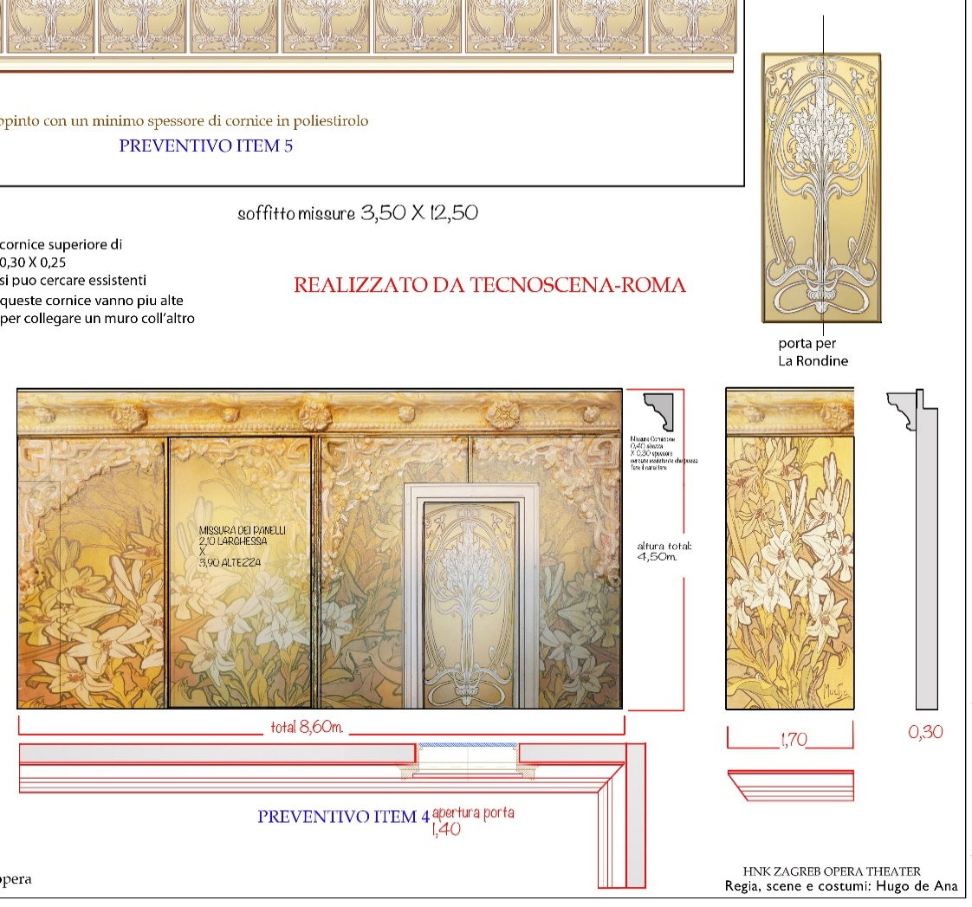
No. 3 set 1
Wreath as a part of the Lastavica performance set

TENDER LIST
Subject of procurement: PROCUREMENT OF WALLS WITH FRAMES AND DOORS AND A WREATH TO DECORATE THE STAGE

The Contracting Authority is the Croatian National Theatre in Zagreb, Trg Republike Hrvatske 15, 10000 Zagreb, MB: 3205470, OIB: 10852199405, telephone: 014888 403, facsimile: 014888417, www.hnk.hr

Information on the offeror or members of the consortium of offerors if involving a consortium of offerors

- Name, headquarters and address of the offer or members of the consortium of offerors:

__________________________________________________________________
VAT ID no. (or national identification number according to the economic entity’s host country, if applicable);
________________________________________________________________________
Account number:
Offeror is registered within the VAT system YES NO
(circle one of the provided options)
Address for delivery of post and email address:
________________________________________________________________________

Contact person: ___________________
Telephone number: ________________ Facsimile number:_________________________

- Name, headquarters and address of the member of the consortium of offerors:

____________________________________________________________________
VAT ID no. (or national identification number according to the economic entity’s host country, if applicable);

________________________________________________________________________
Account number:
Offeror is registered within the VAT system YES NO
(circle one of the provided options)
Address for delivery of post and email address:

Contact person: ____________________
Telephone number: _________________ Facsimile number:________________________

- Name, headquarters and address of the member of the consortium of offerors:

________________________________________________________________________
VAT ID no. (or national identification number according to the economic entity’s host country, if applicable);

________________________________________________________________________
Account number:
Offeror is registered within the VAT system YES NO
(circle one of the provided options)
Address for delivery of post and email address:

Contact person: ____________________
Telephone number: _________________ Facsimile number:________________________

NOTE: If the offeror is not registered within the VAT system or the subject of procurement is exempted from VAT, it is then necessary to write on the tender list on the envisaged place for entering the price of the offer including VAT, the same amount as is entered in the envisaged place for entering the price of the offer excluding VAT, where the envisaged place for entering the VAT amount is left empty.

Validity period of the offer: 60 days.
Deadline, manner and conditions of payment: The charging for and payment of goods will be carried out after the signing of the accepted invoices by the Contracting Authority, all in accordance with the actual delivery quantities of services referred to in the Bill-of-Quantities.

The Contracting Authority is obliged to pay the certified the indisputable part of the invoice within a period of 30 (thirty) days from the date of receiving the invoice.

Place of delivery: Croatian National Theatre in Zagreb Trg Republike Hrvatske 15, Zagreb

At _______________, on ______/_______/ 20___
(place) (date: day/month/year)

THE OFFEROR
__________________________
(seal and signature of authorised person)

Zagreb, 13/07/2021

